**The Arduino ecosystem**

**Circuit boards + code + community ♥ = Arduino**

the whole Arduino Ecosystem which is made up of:

* A family of boards that can be used to make electronic assemblies. There are different sizes and colors and each has different features (below left, an Arduino UNO and, right, an Arduino Nano):  
  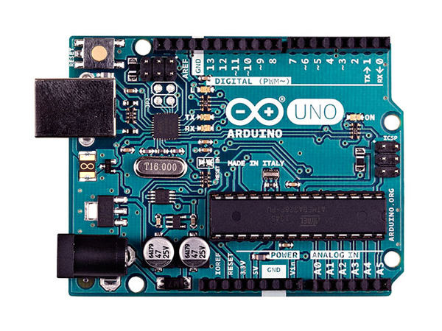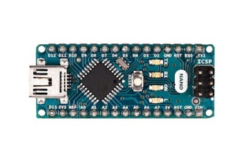
* Computer software, called the Arduino IDE (Integrated Development Environment), which allows us to send instructions to the board. This software allows you to type instructions in the Arduino programming language (which is very similar to the C language). This is the famous Arduino code which we're going to discover this week. Here’s what the code looks like:  
  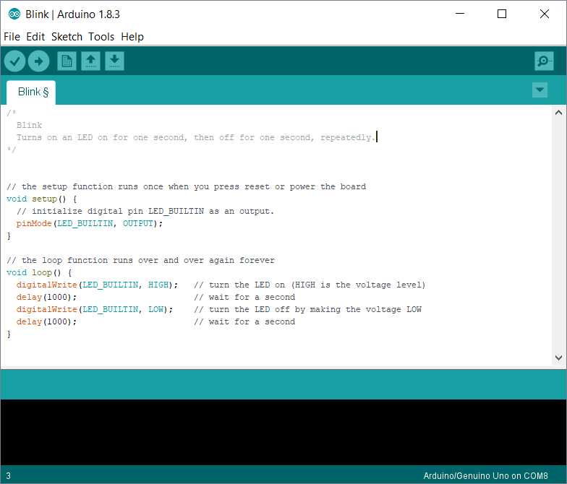  
  Finally, there is a global Arduino community that carries out incredible projects and documents them on the Internet (like the blog of the site <http://www.arduino.cc>):

[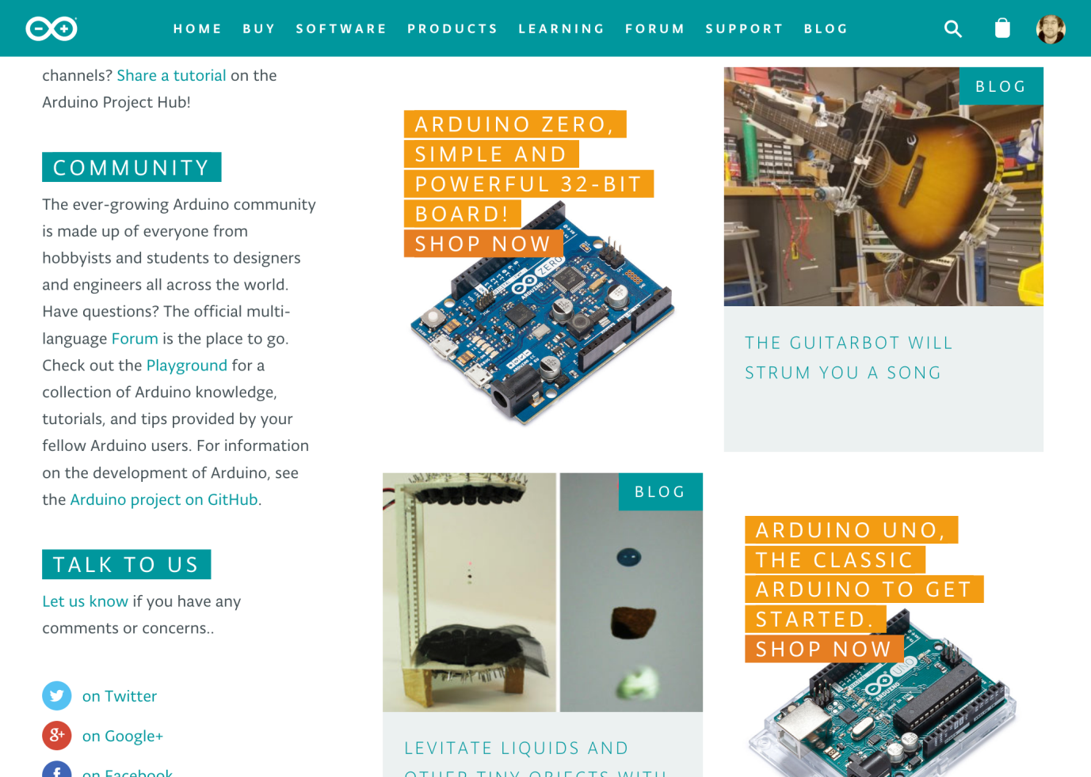](https://blog.arduino.cc/)

**The history of Arduino**

Created in Ivrea, Italy, in the mid-2000’s, the idea behind Arduino was to create a circuit board that was easily programmable by non-experts.

They wanted this card to be modular (suitable for use in robotics, in art, to build machines...), low-cost (< €20) and open-source (meaning that the recipe for its creation is available for free on the Internet, so that people can take the plans and make their own variants). This formula has proven so successful that today tens of thousands of artists, designers, engineers, researchers, teachers and even companies use it to carry out incredible projects, such as:

* Capturing and analyzing scientific data from sensors for educational, research or citizen appropriation purposes;
* Live shows – thanks to the many interaction features offered by Arduino, it is possible to create performances in [VJing](https://en.wikipedia.org/wiki/VJing" \t "[object Object]) (DJ video), which generates real-time sound and visual effects from dancers’ movements;
* Digital art installations – Arduino allows for the realization of works of art which can interact independently with the public;
* Artisanal production of digital objects and low-cost machine tools in the perspective of a culture of technological appropriation that promotes DIY and organizing;
* Rapid prototyping of innovative projects using electronics, since Arduino facilitates easy and cheap experimentation before manufacturing;
* Fashion and textile design – several designers are exploring the possibilities offered by the integration of electronics in clothing (e-textiles);
* Educational projects for students, professionals or the general public, from universities (such as our MOOCs), to specialized training centers or FabLabs

To see more ideas for what you can do with Arduino, check out Arduino's own [project ideas website](https://playground.arduino.cc/Projects/Ideas), [Hackster.io's Arduino page](https://www.hackster.io/arduino/projects" \t "[object Object]) and this page from [Circuitdigest](https://circuitdigest.com/arduino-projects" \t "[object Object]).

## Software for writing and checking your code

This week you’re going to learn how to type code to tell Arduino what to do. There are **three tools** you need for this:

1.                 The **Arduino IDE**is the preferred tool to use with the Arduino board, as it allows you to upload code to your Arduino board via USB. This software requires installation on your Windows, Linux or Mac computer.

2.                 Second, the **Autodesk circuits simulator (TinkerCad)**will allow you to test your code and electronic fixtures, virtually. this runs in your web browser, and no software installation on your computer is required.

## Installation of the Arduino software

You are the proud owner of an Arduino board, and it's nearly time to upload your first program! For this you will need to install the Arduino computer software (also called the IDE, which stands for Integrated Development Environment).

### Tutorial

1. Go to the official website ([arduino.cc](http://arduino.cc/)) and click on **Downloads** under the **Software** tab on the navigation bar.

* On the page that opens, click the version that corresponds to your operating system
* Once the software is downloaded, click on the installer and follow the procedure (you must have administrator rights to install the drivers under Windows and Mac OS).
* Launch the software and open the Blink example code by clicking on File > Examples > 01. Basics > Blink:
* The Arduino IDE has a simple look and feel. The window you can see now has only a small number of buttons whose main functions are listed below:
* 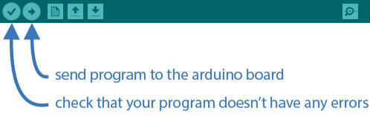

1. Once you’ve got the Blink example open, you should see the following code:

// Number of the pin connected to the LED:  
int led = 13;

// the function runs once when you press reset or power the board

void **setup**() {

// initialize digital pin 'led' as an output.

  pinMode(led, OUTPUT);

}

// this code runs over and over again as long as there is power

void **loop**() {

  digitalWrite(led, HIGH); // light LED (send 5V to the pin)

  delay(1000); // wait 1000ms = 1s

  digitalWrite(led, LOW); // turn off LED (0V to the pin)

  delay(1000); // wait another second

}